Deform to fit on the over decimation version
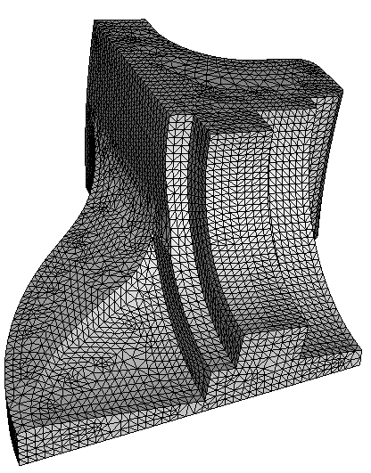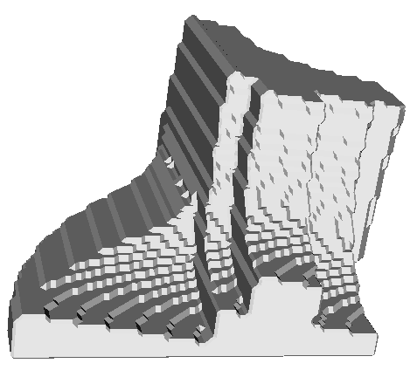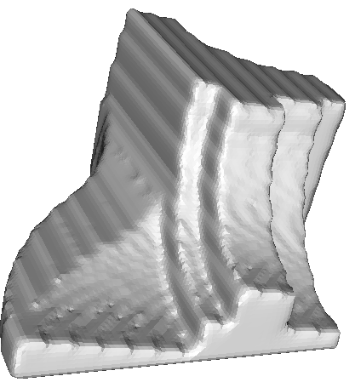
1. Original mesh 2. Non-obtuse mesh (20545 vertices) 3. Constraint Laplace smoothing 2 times
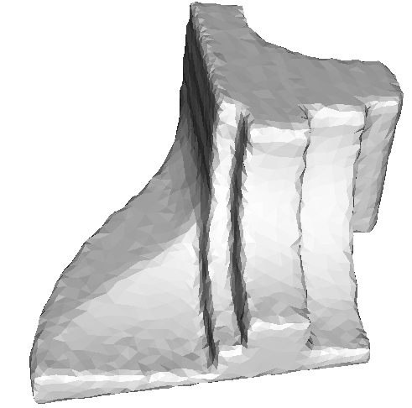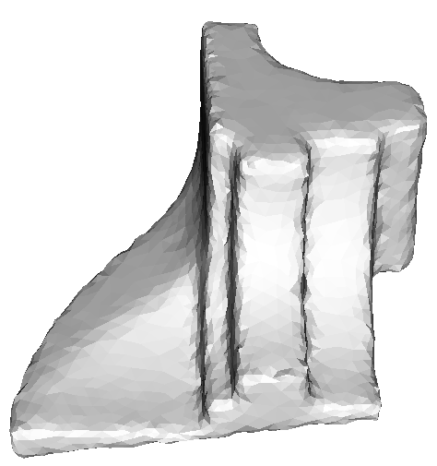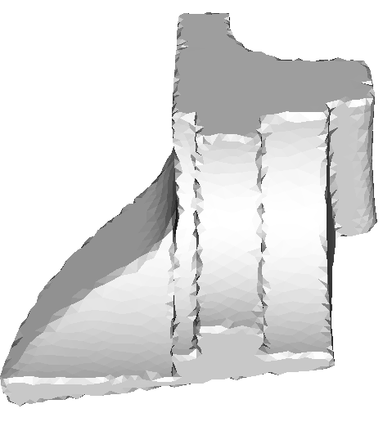
4. Decimation (3000 vertices) 5.Constraint Laplace smoothing 1 times 6. Deform to fit 2 times
The steps: smoothing, decimation, smoothing, and deform-to-fit.

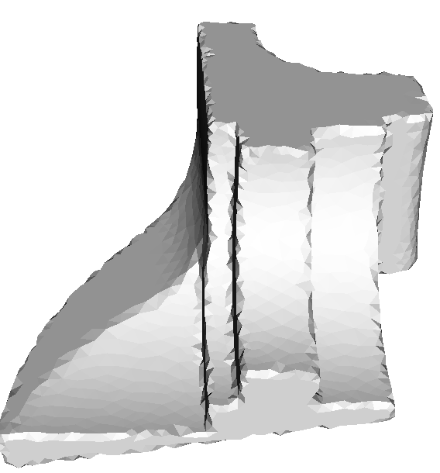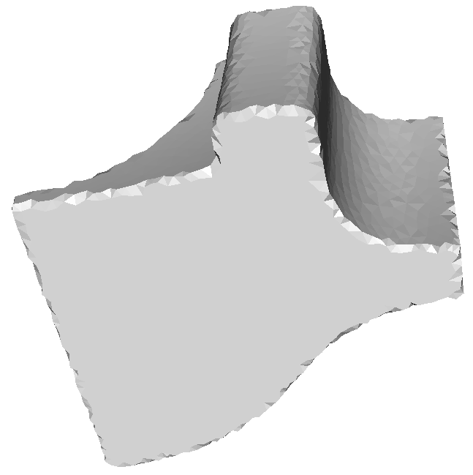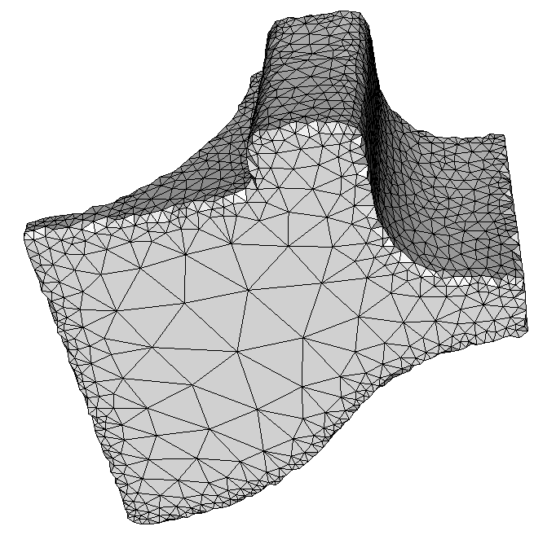
The zoomed final result

